Dealing with ${\left(a+b\right)}^{n}$

Remember ${\left(a+b\right)}^{n}=a^{n}{\left(1+\frac{b}{a}\right)}^{n}$

Examples
1. Find first four terms in the binomial expansion of $\sqrt{4+x}$. State the values of $x$ for which the expansion is valid.

Quickfire First Step
What would be the first step in finding the Binomial expansion of each of these?

 | First Step… | Valid when?
1. ${\left(2+x\right)}^{-3}$
2. ${\left(9+2x\right)}^{\frac{1}{2}}$
3. ${\left(8-x\right)}^{\frac{1}{3}}$
4. ${\left(5-2x\right)}^{-3}$
5. ${\left(16+3x\right)}^{-\frac{1}{2}}$

Test Your Understanding
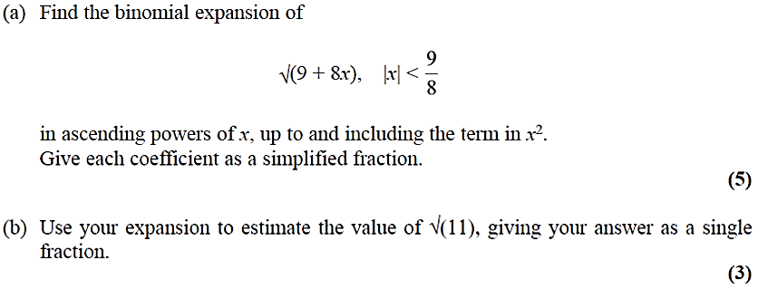

Extension
[AEA 2006 Q1]
- For $\left|y\right|<1$, write down the binomial series expansion of ${\left(1-y\right)}^{-2}$ in ascending powers of $y$ up to and including the term in $y^{3}$.
- Hence, or otherwise, show that
$$1+\frac{2x}{1+x}+\frac{3x^{2}}{{\left(1+x\right)}^{2}}+…+\frac{rx^{r-1}}{{\left(1+x\right)}^{r-1}}+…$$can be written in the form ${\left(a+x\right)}^{n}$. Write down the values of the integers $a$ and $n$.
- Find the set of values of $x$ for which the series in part (b) is convergent.

Exercise 4B Page 99

